**PHASE 1 EVALUATION:**

**System for washing machines such that whenever it is filled, red LED turns on and if empty a green LED blinks once every 20ms.**

**Circuit Diagram:**

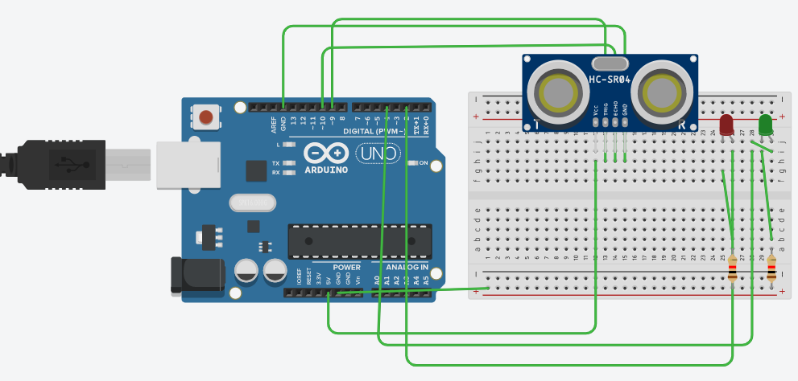

**Theory:**

**Concept used:-**

The concepts used for realization and implementation of the task are:

* The Arduino board supply a power of 5V which we call as HIGH and 0V which we call as LOW digital output signals through the 14 pins present on the Arduino board.
* Concept of ultrasonic distance sensor which is a device consisting of four pins Vcc, TRIG, ECHO, GND.
* And the concept of breadboard where there are two rows each on top and bottom of it, connected to each other:

**Learning and Observations:**

**Leanings:**

* I have learned about distance measurements using ultrasonic distance sensor by connections on breadboard and Arduino.
* Learnings about how a practical problem(such as in my case washing machine) can be solved using BEEE Lab skills and by knowledge of devices like ultrasonic sensor, connections on Arduino and awareness of terms like TRIGGER, ECHO etc.

**Observations:**

* When the code is uploaded the signals are sent to Arduino and LEDs blink accordingly.

**Problems and Troubleshooting:-**

The problems I faced while doing task are:

* The problem of superimposing of many wires so arranging them in order for better clearance.
* Errors in code which could not make the circuit work properly.
* Issue of video uploading which increased the time to complete the given task so working upon speed while performing.

**Precautions**

The precautions that we need to keep in mind while doing this experiment are:

* The wires and the LEDs used should be inserted properly in the breadboard for the hardware to work properly.
* Ensuring that positive terminal of LED is connected to Arduino digital input/output pins and negative terminal to the ground.
* We should take care that the circuit is closed and before uploading the code port and tools should be checked in tools menu.

**Learning Outcomes**

* I have gained knowledge about practical problems and how basic skills of electronics can solve many issues.
* I have got to know about glowing LEDs by running codes on Arduino software and How an ultrasonic distance sensor works in order to print the required output.